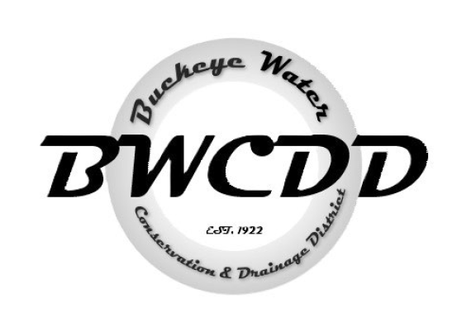

BUCKEYE WATER CONSERVATION
&
DRAINAGE DISTRICT
Pursuant to A.R.S. § 38-431.02,
NOTICE IS HEREBY GIVEN
that a meeting of the Board of Directors of the
Buckeye Water Conservation & Drainage District
will be held on Monday, January 20, 2025 starting at 10:00 am,
at the offices of the Buckeye Water Conservation & Drainage District
205 E. Roosevelt Ave. Buckeye, Arizona 85326.

*The board meeting agenda, minutes, financials and executive session documents will be sent in two separate emails prior to the meeting.

